DUB-IY Short manual

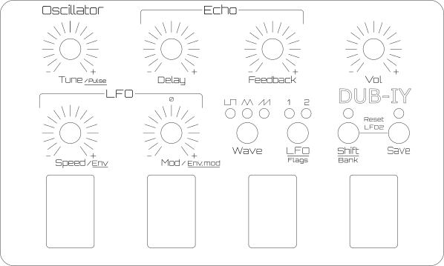
Frequency
20 Hz - 14kHz
Delaytime
Echo-Effekt
Echo Mix and
Feedback
Dry … infinete Loop
Master
Volume

